Puck Yeah Deployment Plan

Puck Yeah is a web based multiplayer air hockey game.

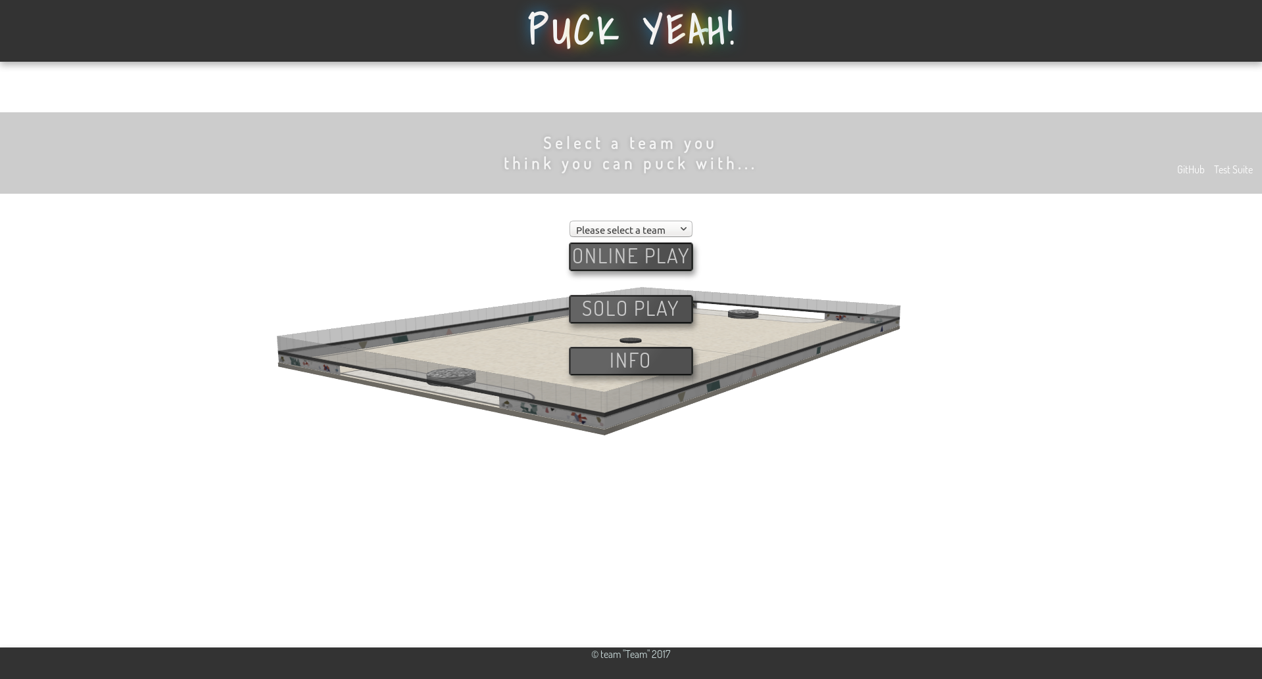

Because this is an online game, a server must be constructed to host the game. Because the game was created using node.js, this is rather simple task. However, as the game stands, only two people can play at a time. This can be fixed by implementing rooms through socket.io, a framework used to handle the networking aspect of Puck Yeah.



Because node.js is so versatile, it can be run on most machines, like JavaScript. Getting a machine to host two players for Puck Yeah is not challenging, as most laptops are powerful enough to process data at that rate. Although, as the number of concurrent players increases, the computational load on the server increases as well.

For only a single session (data being sent between two players), quite a bit of information must be exchanged between the server and the clients.



The screenshot above shows the server console sending the puck location between the two clients. In reality, the clients exchange far more information than this. The clients clients send their session id’s (a unique string of characters for each client), puck position (a 3D vector of floats), puck linear velocity (a 3D vector of floats), puck angular velocity (a 3D vector of floats), and striker position (a 3D vector of floats). While this data may seem insignificant for a server, one must remember, this process of sending data to and from the server, happens at the same rate at which the game refreshes. Furthermore, once different sessions, or rooms, would have been implemented, the server must further route incoming data to the correct clients, instead of sending information about every game to every other game. In other words, a ton of data is being processed by the server.

To handle data on this scale, both a powerful computer and a fast network connection. The game could be placed on a desktop computer in the price range of about $1000 would suffice for a playerbase in the thousands.



The internet connection for this server must be rather quick and reliable. Depending on the number of people playing, a gigabit connection could be required, which would cost about $80 per month.

To allow people to easily access this game from their browsers, a domain name must be purchased for Puck Yeah. Many sites, such as Google, GoDaddy, or Domain.com, sell these domain names for low prices. Depending on the availability, a domain can be purchased for about $10 per month.

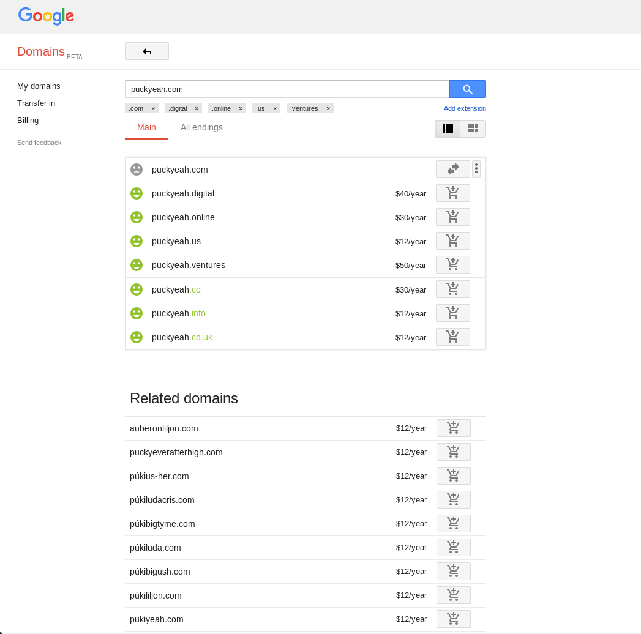 And that’s it! Once you obtain a rather powerful computer to act as the server, a dependable internet connection, and a domain, you’re good to go! In total, hosting a game like Puck Yeah for thousands of players would cost about $120 per month.